LAB REPORT



#### ICT (“Information & Communication Technology Fundamental”)

#### For the degree of Bachelor of Science

#### In Computer Science

#### Session [2k24]

###### Name: Muhammad Wasif Bhatti

**Roll NO: (2k24-BSCS-536)**

**Section: M**

##### Submitted To: Ma’am Fabia Hassan

##### Submitted By: Wasif Bhatti

### **Date: 22 December 2024**

LAB NO: 1

TYPING MASTER

STEP 1 : OPEN TYPING MASTER

1. Double click typing master
2. Alternatively, Search for “Typing Master” in the start menu and click on it.

**Step 2: Select Your Profile (if prompted):**

1. Choose your profile or create a new one.

**Step 3: Click Lessons:**

1. Locate the “Lessons” or “Exercise” tab.

**Step 4: Start First Exercise:**

1. Click on “Lesson 1” or “Exercise 1” (Typically “Home Row”).
2. Press “Start” or “Begin” to commence the exercise.

**Step 5: Begin Typing**

Follow on – screen instructions and start typing.

**INTERNAL COMPONENTS OF COMPUTER**

• Central Processing Unit (CPU)

• Motherboard

• Random Access Memory (RAM)

• Power Supply Unit (PSU)

• Graphics Processing Unit (GPU)

• Storage Drives

* Hard Disk Drive (HDD)
* Solid State Drive (SSD)

• Cooling System

* CPU Cooler (Fan or Liquid Cooling)
* Case Fans

LAB 02

How To Install Windows

**Steps :**

1. **Create a bootable USB drive** with the Windows installation media.
2. **Insert the USB drive** into the computer and restart.
3. **Enter BIOS/UEFI settings** (usually by pressing F2, F10, or Delete during startup).
4. **Set the USB drive as the primary boot device** in the boot order.
5. **Save and exit BIOS/UEFI** to restart from the USB.
6. **Select your language, time, and keyboard preferences** in the Windows Setup window.
7. **Click "Install Now"** and enter your product key if prompted.
8. **Choose the installation type** (Upgrade or Custom for a clean install).
9. **Select the drive/partition** where you want to install Windows.
10. **Wait for Windows to install** and follow the prompts to set up your account and preferences.

Once complete, Windows will restart and boot into the new installation.

CPU ASSEMBLLING

STEPS

1. **Prepare the motherboard** by placing it on a flat, static-free surface.
2. **Open the CPU socket latch** on the motherboard.
3. **Align and place the CPU** into the socket without forcing it.
4. **Secure the CPU** by lowering the latch.
5. **Apply thermal paste** on the CPU if not already on the cooler.
6. **Attach the CPU cooler** and secure it in place.

LAB 03

MotherBoard and its Internal Structures

A **motherboard** is the main circuit board in a computer or other electronic devices. It acts as the backbone that connects all the key components, enabling them to communicate and work together.

Internal structures

• CPU Socket

• Chipset

• RAM Slots

• BIOS/UEFI Chip

• Power Connectors

• VRM (Voltage Regulator Module)

• PCIe Slots

• M.2 Slots

• SATA Ports

• Internal USB Headers

• Fan Headers

• Audio Header

• Network Interface

• CMOS Battery

• Debug LEDs/POST Display

• Heat Sinks

• Debug Buttons

• Front-Panel Connectors

LAB 04

INTRO TO MS WORD, MS WORD BASIC FEATURES

Microsoft Word, often referred to as **MS Word**, is a widely used **word processing application** developed by Microsoft. It is a part of the **Microsoft Office Suite** and is designed for creating, editing, formatting, and sharing text documents. MS Word is known for its user-friendly interface and powerful tools, making it a popular choice for personal, educational, and professional use.

MS WORD BASIC FEATURES

* Text editing and formatting
* Page layout and design
* Paragraph formatting
* Inserting elements
* Templates
* Navigation tools
* Proofing tools
* Saving and exporting

LAB 05

ADVANCED MS WORD FEATURES

MAIL MERGE

JOB

**OBC Company**  
123 Main Street, Cityville  
24-11-2024

**Subject: Job Offer Confirmation**

Dear John,

We are pleased to offer you the position of **Marketing Assistant** at **ABC Company**, starting on **December 1, 2024**. You will report to **Ms. Jane Doe**. Your salary will be **$45,000 per year**, with benefits as discussed.

Please confirm your acceptance by signing below. We look forward to working with you!

Sincerely,  
Sarah Johnson  
HR Manager  
ABC Company

STEPS FOR MAIL MERGE

**Step 1: Prepare Your Data Source**

* Create a data file containing the information you want to merge. This can be a table in:
  + **Microsoft Excel**: Create a spreadsheet with column headers like "Name," "Address," etc.
  + **Microsoft Access** or a simple **Word Table**.
* Save your data source.

**Step 2: Open Microsoft Word**

* Open a blank document or an existing template for your letter, label, or email.

**Step 3: Start the Mail Merge Wizard**

1. Go to the **Mailings** tab in the Ribbon.
2. Click on **Start Mail Merge** and select the type of document:
   * Letters
   * Email Messages
   * Envelopes
   * Labels
   * Directory

**Step 4: Select Recipients**

1. Click **Select Recipients** in the Mailings tab.
2. Choose the source for your data:
   * **Type a New List**: Create a list directly in Word.
   * **Use an Existing List**: Browse to your Excel or Access file.
   * **Select from Outlook Contacts**.

**Step 5: Insert Merge Fields**

1. Place your cursor in the document where you want a personalized detail to appear.
2. Click **Insert Merge Field** in the Mailings tab.
3. Select fields like "Name," "Address," or others from your data source.

**Step 6: Preview the Results**

* Click **Preview Results** to see how your document will look with the data merged.

**Step 7: Complete the Mail Merge**

1. Click **Finish & Merge** in the Mailings tab.
2. Choose an option:
   * **Edit Individual Documents**: Review and edit each document before finalizing.
   * **Print Documents**: Print directly.
   * **Send Email Messages**: Send emails if creating email messages.

**Step 8: Save Your Document**

* Save your merged document or template for future use.

These steps will help you quickly create personalized documents or communications using Mail Merge in Microsoft Word!

TABLE OF CONTENTS

For thedegreeofBachelor ofScience 1

Submitted To: Mam Fabia Hassan 1

Submitted By: Wasif Bha 1

November2024 1

Cristiano Ronaldo 7

Lionel Messi 7

Bibliography 7

STEPS FOR TABLE OF CONTENTS

* Open MS Word.
* Then type your context.
* Then break your paragraphs into different **Headings.**
* Click on **“References”.**
* Then click on **“Table of Content”.**
* Your table of content has been created.
* You can also change your **“Page Color”** from **“Design”** Menu bar**.**
* You can also create **“Header & Footer”.**

You can also create **“Page Numbers”** from **“Insert”** option on Menu bar.

CROSS REFRENCE

STEPS FOR CROSS REFRENCE

* PLACE CURSOR WHERE YOU WANT TO ADD CROSS REFRENCE
* GO TO REFRENCE TAB
* CLICK CROSS REFRENCE
* SELECT REFRENCE TYPE
* CHOOSE SPECIFIC REFRENCE FROM THE LIST
* CLICK INSERT

THERE ARE MANY GREAT FOOTBALL PLAYERS BUT MY FAVOURITES ARE :

* Cristiano Ronaldo
* Lionel Messi
* Bibliography

**Cristiano Ronaldo**

Cristiano Ronaldo dos Santos Aveiro [GOIH](https://en.wikipedia.org/wiki/Order_of_Prince_Henry) [ComM](https://en.wikipedia.org/wiki/Order_of_Merit_(Portugal)) (Portuguese pronunciation: [[kɾiʃˈtjɐnu ʁɔˈnaldu]](https://en.wikipedia.org/wiki/Help:IPA/Portuguese); born 5 February 1985) is a Portuguese professional [footballer](https://en.wikipedia.org/wiki/Association_football) who plays as a [forward](https://en.wikipedia.org/wiki/Forward_(association_football)) for and [captains](https://en.wikipedia.org/wiki/Captain_(association_football)) both [Saudi Pro League](https://en.wikipedia.org/wiki/Saudi_Pro_League) club [Al Nassr](https://en.wikipedia.org/wiki/Al_Nassr_FC) and the [Portugal national team](https://en.wikipedia.org/wiki/Portugal_national_football_team). Widely regarded as one of the greatest players of all time, Ronaldo has won five [Ballon d'Or](https://en.wikipedia.org/wiki/Ballon_d%27Or) awards,[[note 3]](https://en.wikipedia.org/wiki/Cristiano_Ronaldo#cite_note-12) a record three [UEFA Men's Player of the Year Awards](https://en.wikipedia.org/wiki/UEFA_Men%27s_Player_of_the_Year_Award), and four [European Golden Shoes](https://en.wikipedia.org/wiki/European_Golden_Shoe), the most by a European player. He has won [33 trophies in his career](https://en.wikipedia.org/wiki/List_of_career_achievements_by_Cristiano_Ronaldo#Collective_awards), including seven league titles, five [UEFA Champions Leagues](https://en.wikipedia.org/wiki/UEFA_Champions_League), the [UEFA European Championship](https://en.wikipedia.org/wiki/UEFA_European_Championship) and the [UEFA Nations League](https://en.wikipedia.org/wiki/UEFA_Nations_League). Ronaldo holds the records for most [appearances](https://en.wikipedia.org/wiki/European_Cup_and_UEFA_Champions_League_records_and_statistics#Players) (183), [goals](https://en.wikipedia.org/wiki/List_of_UEFA_Champions_League_top_scorers#All-time_top_scorers) (140) and [assists](https://en.wikipedia.org/wiki/European_Cup_and_UEFA_Champions_League_records_and_statistics#Most_assists) (42) in the Champions League, [most appearances](https://en.wikipedia.org/wiki/List_of_players_who_have_appeared_in_multiple_UEFA_European_Championships#Most_matches) (30), assists (8), [goals in the European Championship](https://en.wikipedia.org/wiki/UEFA_European_Championship_top_goalscorers) (14), [international appearances](https://en.wikipedia.org/wiki/List_of_men%27s_footballers_with_100_or_more_international_caps) (215) and [international goals](https://en.wikipedia.org/wiki/List_of_men%27s_footballers_with_50_or_more_international_goals) (133). He is one of the few players to have made [over 1,200 professional career appearances](https://en.wikipedia.org/wiki/List_of_men%27s_footballers_with_1,000_or_more_official_appearances), the most by an [outfield](https://en.wikipedia.org/wiki/Outfield) player, and has scored [over 900 official senior career goals](https://en.wikipedia.org/wiki/List_of_footballers_with_500_or_more_goals) for club and country, making him the top goalscorer of all time.

Lionel Messi

Lionel Andrés "Leo" Messi[[note 1]](https://en.wikipedia.org/wiki/Lionel_Messi#cite_note-7) (Spanish pronunciation: [[ljoˈnel anˈdɾes ˈmesi]](https://en.wikipedia.org/wiki/Help:IPA/Spanish) [ⓘ](https://en.wikipedia.org/wiki/File:Lionel_Andr%C3%A9s_Messi_-_Name.ogg); born 24 June 1987) is an Argentine professional [footballer](https://en.wikipedia.org/wiki/Association_football) who plays as a [forward](https://en.wikipedia.org/wiki/Forward_(association_football)) for and [captains](https://en.wikipedia.org/wiki/Captain_(association_football)) both [Major League Soccer](https://en.wikipedia.org/wiki/Major_League_Soccer) club [Inter Miami](https://en.wikipedia.org/wiki/Inter_Miami_CF) and the [Argentina national team](https://en.wikipedia.org/wiki/Argentina_national_football_team). Widely regarded as one of the greatest players of all time, Messi set numerous records for [individual accolades](https://en.wikipedia.org/wiki/List_of_career_achievements_by_Lionel_Messi#Individual_honours) won throughout [his professional footballing career](https://en.wikipedia.org/wiki/Career_of_Lionel_Messi) such as eight [Ballon d'Or](https://en.wikipedia.org/wiki/Ballon_d%27Or) awards and eight times being named the [world's best player](https://en.wikipedia.org/wiki/The_Best_FIFA_Men%27s_Player#FIFA_Player_of_the_Year_(including_predecessors)) by [FIFA](https://en.wikipedia.org/wiki/FIFA).[[note 2]](https://en.wikipedia.org/wiki/Lionel_Messi#cite_note-BDOFIFA-13) He is the most decorated player in the history of professional football having won [45 team trophies](https://en.wikipedia.org/wiki/List_of_career_achievements_by_Lionel_Messi#Collective_awards),[[note 3]](https://en.wikipedia.org/wiki/Lionel_Messi#cite_note-2005Supercopa-24) including twelve league titles, four [UEFA Champions Leagues](https://en.wikipedia.org/wiki/UEFA_Champions_League), two [Copa Américas](https://en.wikipedia.org/wiki/Copa_Am%C3%A9rica), and one [FIFA World Cup](https://en.wikipedia.org/wiki/FIFA_World_Cup). Messi holds the [records](https://en.wikipedia.org/wiki/List_of_career_achievements_by_Lionel_Messi#Records) for most [European Golden Shoes](https://en.wikipedia.org/wiki/European_Golden_Shoe) (6), most goals for a single club (672, with [Barcelona](https://en.wikipedia.org/wiki/FC_Barcelona)), most [goals](https://en.wikipedia.org/wiki/List_of_La_Liga_top_scorers#All-time_top_scorers) (474), [hat-tricks](https://en.wikipedia.org/wiki/List_of_La_Liga_hat-tricks) (36) and [assists](https://en.wikipedia.org/wiki/Assist_(association_football)) (192) in [La Liga](https://en.wikipedia.org/wiki/La_Liga), most [matches played](https://en.wikipedia.org/wiki/Copa_Am%C3%A9rica_records_and_statistics#Matches_played) (39), [assists](https://en.wikipedia.org/wiki/Copa_Am%C3%A9rica_records_and_statistics#Individual_records) (18) and [goal contributions](https://en.wikipedia.org/wiki/Copa_Am%C3%A9rica_records_and_statistics#Individual_records) (34) in the Copa América, most [matches played](https://en.wikipedia.org/wiki/List_of_players_who_have_appeared_in_the_most_FIFA_World_Cups) (26) and [goal contributions](https://en.wikipedia.org/wiki/FIFA_World_Cup_records_and_statistics#Goal_contributions) (21) in the World Cup, most [international appearances](https://en.wikipedia.org/wiki/List_of_men%27s_footballers_with_100_or_more_international_caps) (189) and [international goals](https://en.wikipedia.org/wiki/List_of_men%27s_footballers_with_50_or_more_international_goals) (112) by a South American male, and the second-most in the latter category outright. A prolific goalscorer and creative playmaker, Messi has scored over [850 senior career goals](https://en.wikipedia.org/wiki/List_of_footballers_with_500_or_more_goals) for club and country.

Bibliography

https://en.wikipedia.org/wiki/Cristiano_Ronaldo

[https://en.wikipedia.org/wiki/Lionel_Messi](https://en.wikipedia.org/wiki/National_University_of_Computer_and_Emerging_Sciences)

Steps for bibliography

* Go to “Refrence tab”
* Click “Bibilography”
* Select bibliography style
* Choose sources to include from your citation
* Click “OK”

LAB 06

MACROS

**During the insert Citations in this document I Record Macros and Now I only Run the Macros.[1][2]. Here I also used Footnotes and Endnotes.[3]**

**STEPS FOR MACROS**

* **GO TO VIEW TAB**
* **CLICK ON MACROS**
* **THEN SELECT RECORD MACROS**
* **ENTER MACRO NAME**
* **CHOOSE WORD MACROS AS THE LOCATION**
* **CLICK START RECORDING**
* **PERFORM ACTION YOU WANT TO AUTOMATE**
* **CLICK STOP RECORDING**
* **GO TO VIEW TAB**
* **CLICK MACROS**
* **SELECT THE MACRO FROM THE LIST**
* **CLICK RUN**
* **SAVE DOCUMENT WITH MACROS AS “.docm” file**

# Cristiano Ronaldo

Cristiano Ronaldo dos Santos Aveiro [GOIH](https://en.wikipedia.org/wiki/Order_of_Prince_Henry) [ComM](https://en.wikipedia.org/wiki/Order_of_Merit_(Portugal)) (Portuguese pronunciation: [[kɾiʃˈtjɐnu ʁɔˈnaldu]](https://en.wikipedia.org/wiki/Help:IPA/Portuguese); born 5 February 1985) is a Portuguese professional [footballer](https://en.wikipedia.org/wiki/Association_football) who plays as a [forward](https://en.wikipedia.org/wiki/Forward_(association_football)) for and [captains](https://en.wikipedia.org/wiki/Captain_(association_football)) both [Saudi Pro League](https://en.wikipedia.org/wiki/Saudi_Pro_League) club [Al Nassr](https://en.wikipedia.org/wiki/Al_Nassr_FC) and the [Portugal national team](https://en.wikipedia.org/wiki/Portugal_national_football_team). Widely regarded as one of the greatest players of all time, Ronaldo has won five [Ballon d'Or](https://en.wikipedia.org/wiki/Ballon_d%27Or) awards,[[note 3]](https://en.wikipedia.org/wiki/Cristiano_Ronaldo#cite_note-12) a record three [UEFA Men's Player of the Year Awards](https://en.wikipedia.org/wiki/UEFA_Men%27s_Player_of_the_Year_Award), and four [European Golden Shoes](https://en.wikipedia.org/wiki/European_Golden_Shoe), the most by a European player. He has won [33 trophies in his career](https://en.wikipedia.org/wiki/List_of_career_achievements_by_Cristiano_Ronaldo#Collective_awards), including seven league titles, five [UEFA Champions Leagues](https://en.wikipedia.org/wiki/UEFA_Champions_League), the [UEFA European Championship](https://en.wikipedia.org/wiki/UEFA_European_Championship) and the [UEFA Nations League](https://en.wikipedia.org/wiki/UEFA_Nations_League). Ronaldo holds the records for most [appearances](https://en.wikipedia.org/wiki/European_Cup_and_UEFA_Champions_League_records_and_statistics#Players) (183), [goals](https://en.wikipedia.org/wiki/List_of_UEFA_Champions_League_top_scorers#All-time_top_scorers) (140) and [assists](https://en.wikipedia.org/wiki/European_Cup_and_UEFA_Champions_League_records_and_statistics#Most_assists) (42) in the Champions League, [most appearances](https://en.wikipedia.org/wiki/List_of_players_who_have_appeared_in_multiple_UEFA_European_Championships#Most_matches) (30), assists (8), [goals in the European Championship](https://en.wikipedia.org/wiki/UEFA_European_Championship_top_goalscorers) (14), [international appearances](https://en.wikipedia.org/wiki/List_of_men%27s_footballers_with_100_or_more_international_caps) (215) and [international goals](https://en.wikipedia.org/wiki/List_of_men%27s_footballers_with_50_or_more_international_goals) (133). He is one of the few players to have made [over 1,200 professional career appearances](https://en.wikipedia.org/wiki/List_of_men%27s_footballers_with_1,000_or_more_official_appearances), the most by an [outfield](https://en.wikipedia.org/wiki/Outfield) player, and has scored [over 900 official senior career goals](https://en.wikipedia.org/wiki/List_of_footballers_with_500_or_more_goals) for club and country, making him the top goalscorer of all time.

# Lionel Messi

Lionel Andrés "Leo" Messi[[note 1]](https://en.wikipedia.org/wiki/Lionel_Messi#cite_note-7) (Spanish pronunciation: [[ljoˈnel anˈdɾes ˈmesi]](https://en.wikipedia.org/wiki/Help:IPA/Spanish) [ⓘ](https://en.wikipedia.org/wiki/File:Lionel_Andr%C3%A9s_Messi_-_Name.ogg); born 24 June 1987) is an Argentine professional [footballer](https://en.wikipedia.org/wiki/Association_football) who plays as a [forward](https://en.wikipedia.org/wiki/Forward_(association_football)) for and [captains](https://en.wikipedia.org/wiki/Captain_(association_football)) both [Major League Soccer](https://en.wikipedia.org/wiki/Major_League_Soccer) club [Inter Miami](https://en.wikipedia.org/wiki/Inter_Miami_CF) and the [Argentina national team](https://en.wikipedia.org/wiki/Argentina_national_football_team). Widely regarded as one of the greatest players of all time, Messi set numerous records for [individual accolades](https://en.wikipedia.org/wiki/List_of_career_achievements_by_Lionel_Messi#Individual_honours) won throughout [his professional footballing career](https://en.wikipedia.org/wiki/Career_of_Lionel_Messi) such as eight [Ballon d'Or](https://en.wikipedia.org/wiki/Ballon_d%27Or) awards and eight times being named the [world's best player](https://en.wikipedia.org/wiki/The_Best_FIFA_Men%27s_Player#FIFA_Player_of_the_Year_(including_predecessors)) by [FIFA](https://en.wikipedia.org/wiki/FIFA).[[note 2]](https://en.wikipedia.org/wiki/Lionel_Messi#cite_note-BDOFIFA-13) He is the most decorated player in the history of professional football having won [45 team trophies](https://en.wikipedia.org/wiki/List_of_career_achievements_by_Lionel_Messi#Collective_awards),[[note 3]](https://en.wikipedia.org/wiki/Lionel_Messi#cite_note-2005Supercopa-24) including twelve league titles, four [UEFA Champions Leagues](https://en.wikipedia.org/wiki/UEFA_Champions_League), two [Copa Américas](https://en.wikipedia.org/wiki/Copa_Am%C3%A9rica), and one [FIFA World Cup](https://en.wikipedia.org/wiki/FIFA_World_Cup). Messi holds the [records](https://en.wikipedia.org/wiki/List_of_career_achievements_by_Lionel_Messi#Records) for most [European Golden Shoes](https://en.wikipedia.org/wiki/European_Golden_Shoe) (6), most goals for a single club (672, with [Barcelona](https://en.wikipedia.org/wiki/FC_Barcelona)), most [goals](https://en.wikipedia.org/wiki/List_of_La_Liga_top_scorers#All-time_top_scorers) (474), [hat-tricks](https://en.wikipedia.org/wiki/List_of_La_Liga_hat-tricks) (36) and [assists](https://en.wikipedia.org/wiki/Assist_(association_football)) (192) in [La Liga](https://en.wikipedia.org/wiki/La_Liga), most [matches played](https://en.wikipedia.org/wiki/Copa_Am%C3%A9rica_records_and_statistics#Matches_played) (39), [assists](https://en.wikipedia.org/wiki/Copa_Am%C3%A9rica_records_and_statistics#Individual_records) (18) and [goal contributions](https://en.wikipedia.org/wiki/Copa_Am%C3%A9rica_records_and_statistics#Individual_records) (34) in the Copa América, most [matches played](https://en.wikipedia.org/wiki/List_of_players_who_have_appeared_in_the_most_FIFA_World_Cups) (26) and [goal contributions](https://en.wikipedia.org/wiki/FIFA_World_Cup_records_and_statistics#Goal_contributions) (21) in the World Cup, most [international appearances](https://en.wikipedia.org/wiki/List_of_men%27s_footballers_with_100_or_more_international_caps) (189) and [international goals](https://en.wikipedia.org/wiki/List_of_men%27s_footballers_with_50_or_more_international_goals) (112) by a South American male, and the second-most in the latter category outright. A prolific goalscorer and creative playmaker, Messi has scored over [850 senior career goals](https://en.wikipedia.org/wiki/List_of_footballers_with_500_or_more_goals) for club and country.

Steps for insert citation

* PLACE THE CURSOR WHERE YOU WANT TO ADD CITATION
* GO TO REFRENCE TAB
* CLICK INSERT CITATION
* SELECT CITATION STYLE
* END SOURCE DETAILS
* CLICK OK

LAB 07

HOW TO PROTECT FILE AND ADD PASSWORD

STEPS FOR ADDING PASSWORD

* OPEN DOCUMENT IN MS WORD
* GO TO “FILE > INFO”
* CLICK “PROTECT DOCUMENT”
* SELECT “ENCRYPT WITH PASSWORD”
* ENTER PASSWORD
* RE-ENTER PASSWORD TO CONTINUE
* CLICK OK

LAB 08

FORMULAS OF EXCEL

SUM FORMULA

* Open MS EXCEL
* Open a new sheet
* Merge and centre two or more row and columns and add heading of SUM
* Than make 2 or 3 columnsfor items & price
* Then put diff values in diff cells
* After putting values we use formula = SUM ( RANGE OF CELLS) and then press enter
* The total is calculated at the point where we use formula.

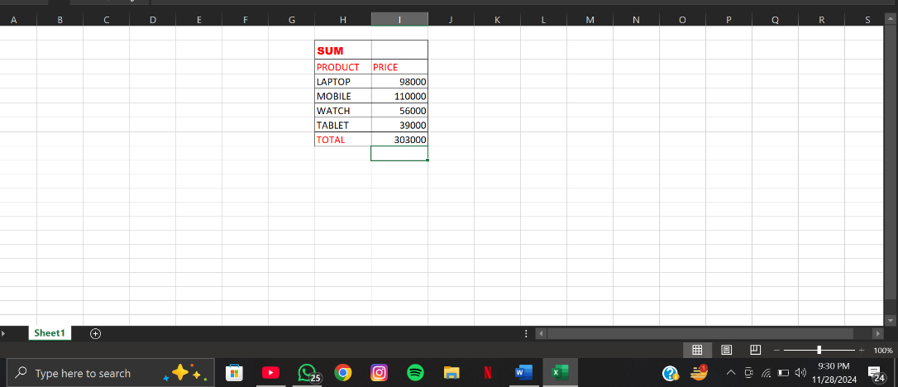

PRODUCT FORMULA

* Open MS EXCEL
* Open a new sheet
* Merge & center 2 or more rows and columns for heading a formula “ PRODUCT “
* Then make 2 or 3 columns for items quantity and price
* Then put diff values in diff cells
* After putting values use formula =PRODUCT( range of cells ) and then press enter
* The total is calculated where we have used the formula

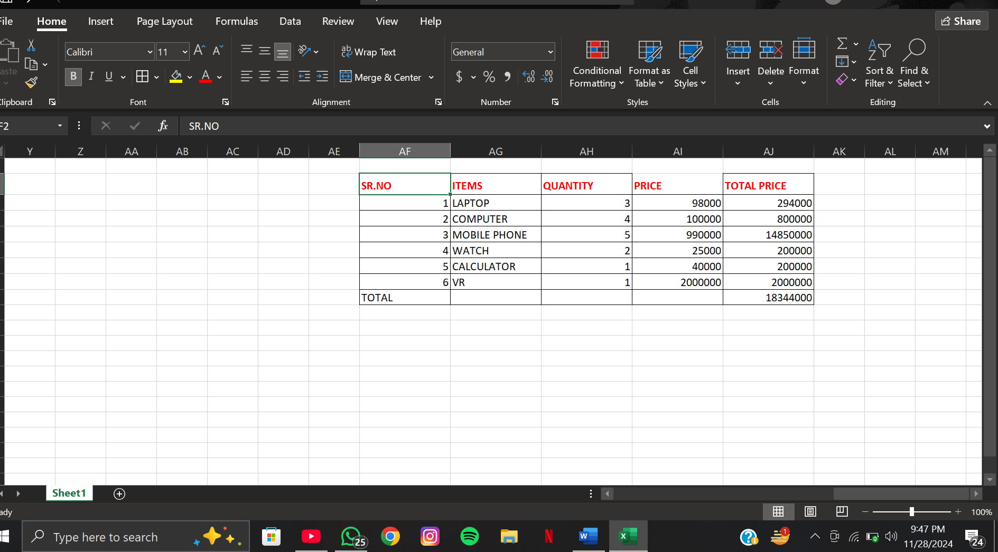

PROPER FORMULA

* Open MS EXCEL
* Open a new sheet
* Merge and centre two or more row and columns and add heading of PROPER
* Than make 2 or 3 columns for items & price
* Then put diff values in diff cells
* After putting values we use formula = PROPER ( RANGE OF CELLS) and then press enter

The total is calculated at the point where we use formula

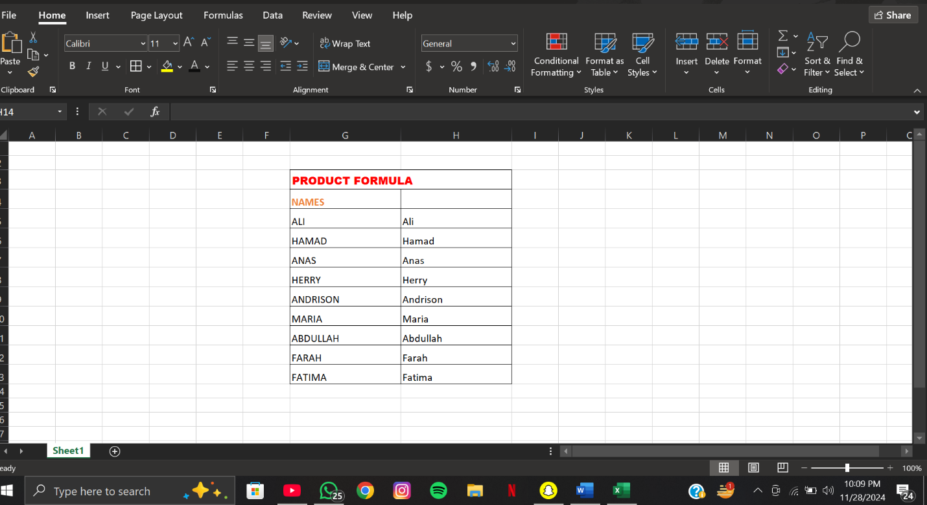

MAX FORMULA

* Open MS EXCEL
* Open a new sheet
* Merge and centre two or more row and columns and add heading of MAX
* Than make 2 or 3 columnsfor items & price
* Then put diff values in diff cells
* After putting values we use formula = MAX( RANGE OF CELLS) and then press enter
* The total is calculated at the point where we use formula.

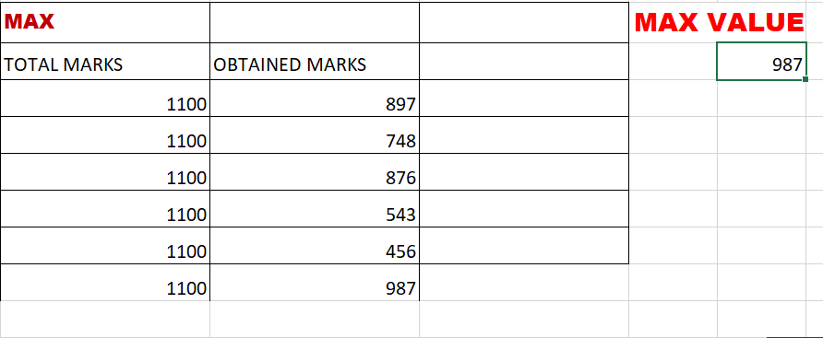

MIN FORMULA

* Open MS EXCEL
* Open a new sheet
* Merge and centre two or more row and columns and add heading of SUM
* Than make 2 or 3 columnsfor items & price
* Then put diff values in diff cells
* After putting values we use formula = MIN ( RANGE OF CELLS) and then press enter
* The total is calculated at the point where we use formula.

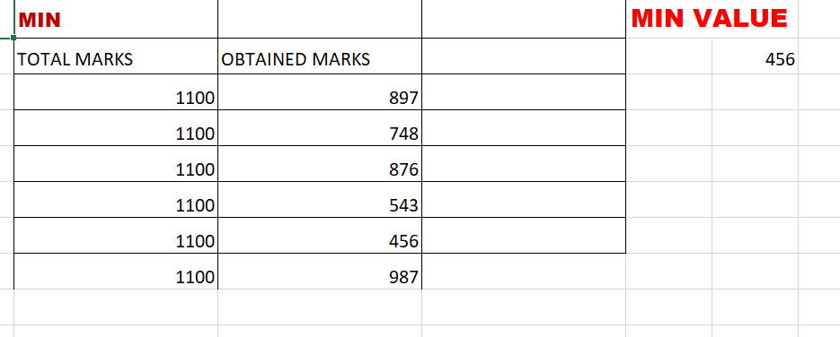

LARGE FORMULA

* Open MS EXCEL
* Open a new sheet
* Merge and centre two or more row and columns and add heading of SUM
* Than make 2 or 3 columnsfor items & price
* Then put diff values in diff cells
* After putting values we use formula = LARGE( RANGE OF CELLS) and then press enter
* The total is calculated at the point where we use formula.

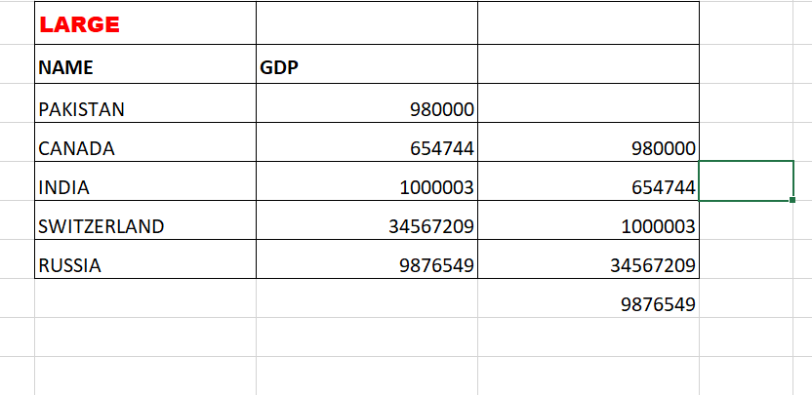

SMALL FORMULA

* Open MS EXCEL
* Open a new sheet
* Merge and centre two or more row and columns and add heading of SUM
* Than make 2 or 3 columnsfor items & price
* Then put diff values in diff cells
* After putting values we use formula = SMALL( RANGE OF CELLS) and then press enter
* The total is calculated at the point where we use formula.

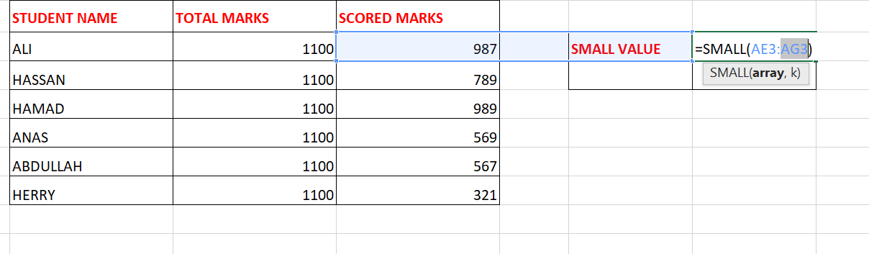

DATE FORMULA

* Open MS EXCEL
* Open a new sheet
* Use formula CONTROL + COLON and then press enter
* The date is shown.

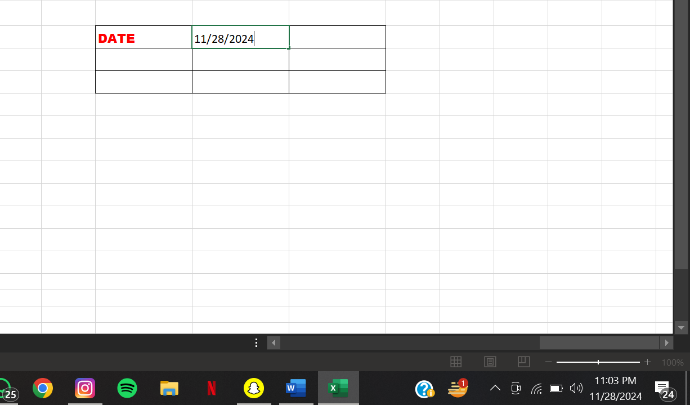

TIME FORMULA

* Open MS EXCEL
* Open a new sheet
* Merge and centre two or more row and columns
* Use formula CTRL+SHIFT+COLON and then press enter
* The Time is shown.

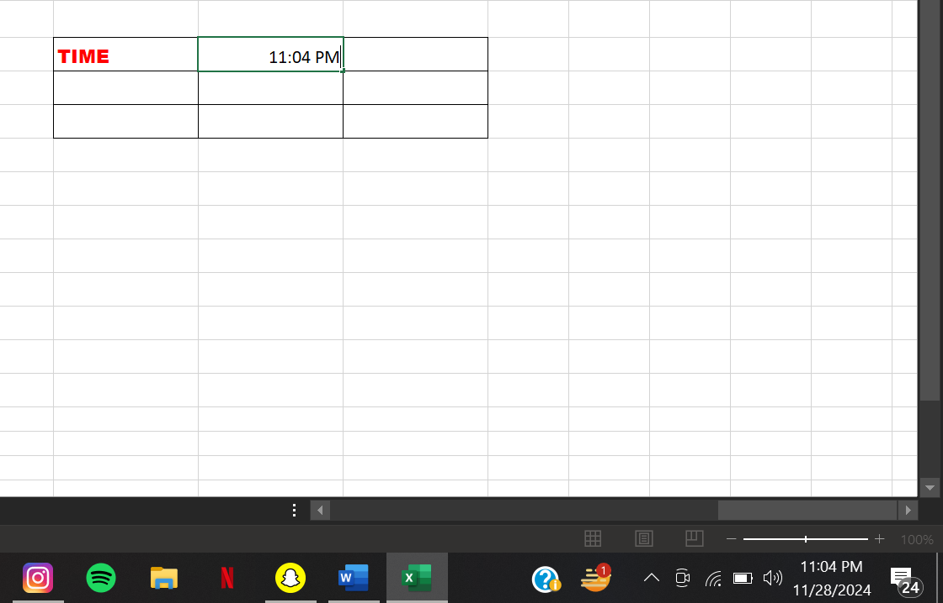

TODAY FORMULA

* Open MS EXCEL
* Open a new sheet
* Use formula = TODAY ( ) and then press enter
* The today is shown.

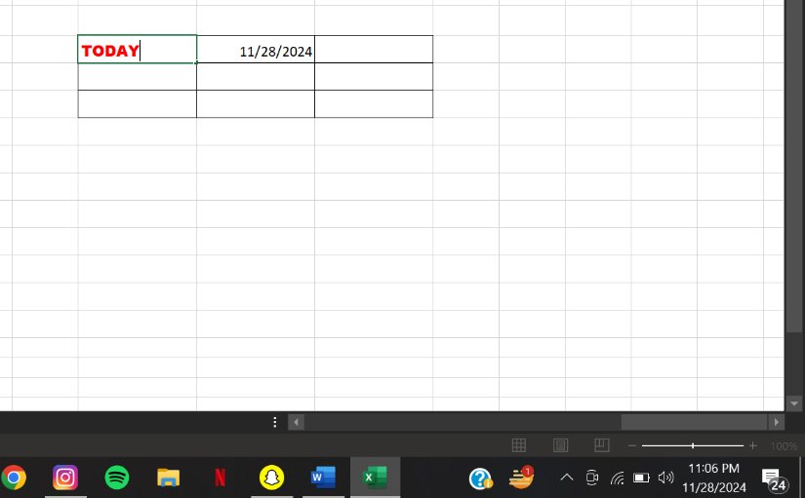

NOW FORMULA

* Open MS EXCEL
* Open a new sheet
* Merge and centre two or more row and columns and add heading of SUM
* Than make 2 or 3 columnsfor items & price
* Then put diff values in diff cells
* After putting values we use formula = SUM ( RANGE OF CELLS) and then press enter
* The total is calculated at the point where we use formula.

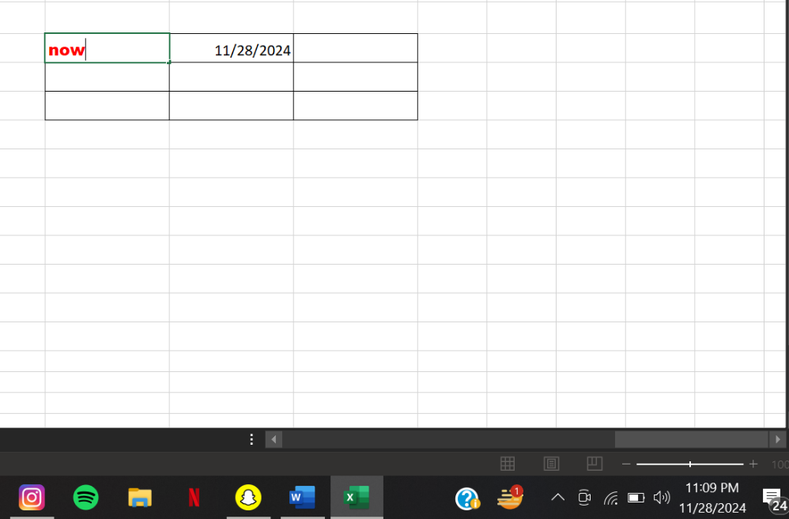

LEN FORMULA

* Open MS EXCEL
* Open a new sheet
* Merge and centre two or more row and columns and add heading of LEN
* Than make 2 or 3 columns.
* Then put diff values in diff cells
* After putting values we use formula = LEN( RANGE OF CELLS) and then press enter
* The total is calculated at the point where we use formula.

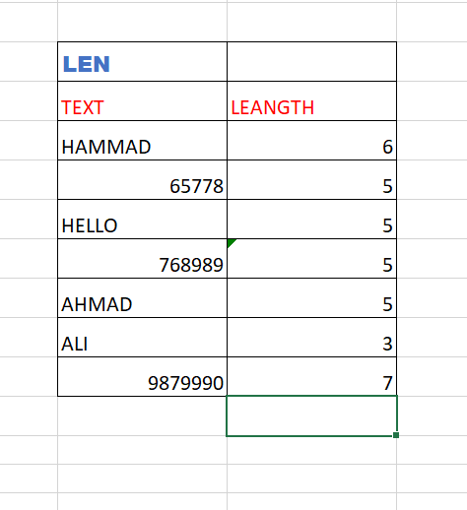

COUNT FORMULA

* Open MS EXCEL
* Open a new sheet
* Merge and centre two or more row and columns and add heading of COUNT
* Than make 2 or 3 columns
* Then put diff values in diff cells
* After putting values we use formula = COUNT( RANGE OF CELLS) and then press enter
* The total is calculated at the point where we use formula.

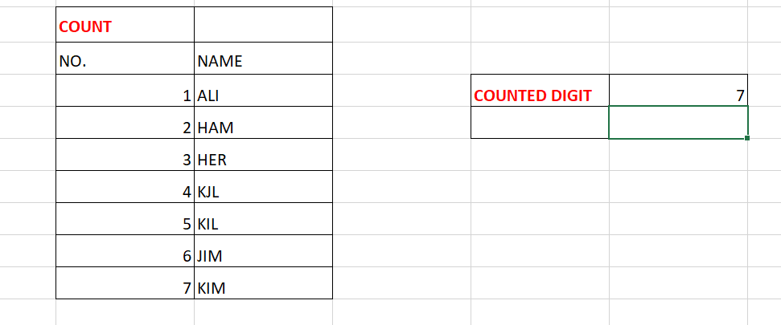

COUNTA FORMULA

* Open MS EXCEL
* Open a new sheet
* Merge and centre two or more row and columns and add heading of COUNTA
* Than make 2 or 3 columns
* Then put diff values in diff cells
* After putting values we use formula = COUNTA( RANGE OF CELLS) and then press enter
* The total is calculated at the point where we use formula.

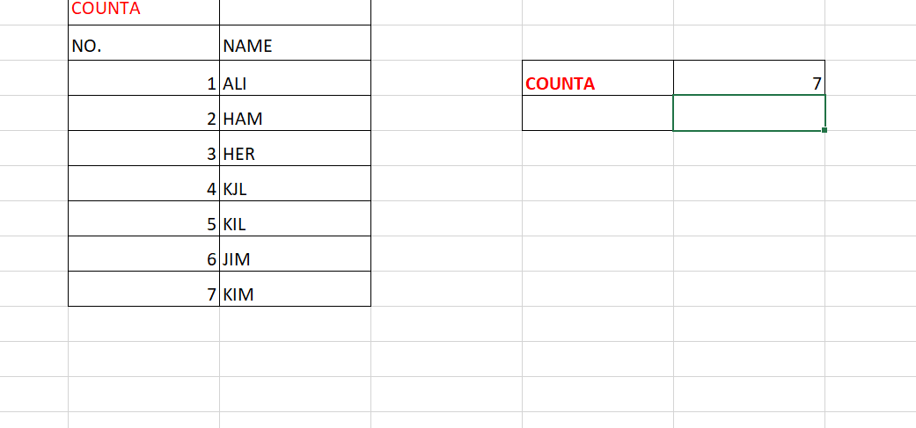

COUNT BLANK FORMULA

* Open MS EXCEL
* Open a new sheet
* Merge and centre two or more row and columns and add heading of COUNTBLANK
* Than make 2 or 3 columnS
* Then put diff values in diff cells
* After putting values we use formula = COUNTBLANK( RANGE OF CELLS) and then press enter
* The total is calculated at the point where we use formula.

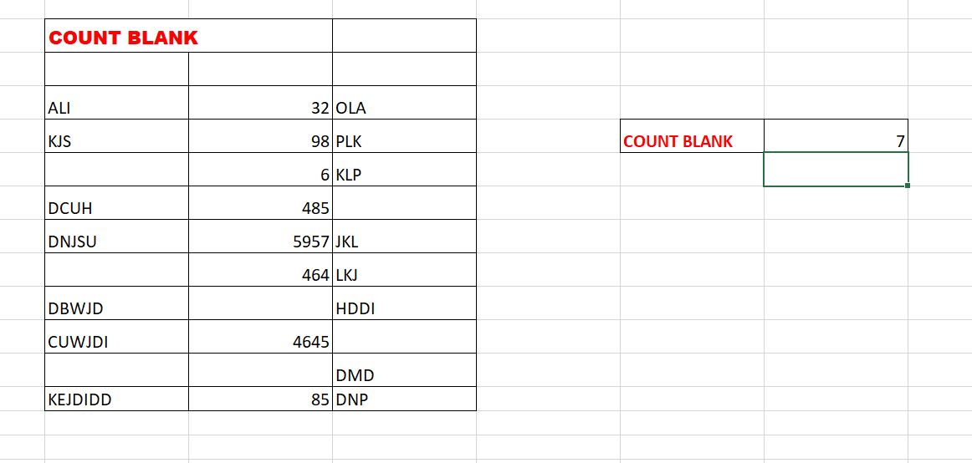

CONCATENATE FORMULA

* Open MS EXCEL
* Open a new sheet
* Merge and centre two or more row and columns and add heading of first name & last name.
* Than make 2 or 3 columns
* Then put diff values in diff cells
* After putting values we use formula = CONCATENATE (select first name ,”space”,select last name) and then press enter
* The total is calculated at the point where we use formula.

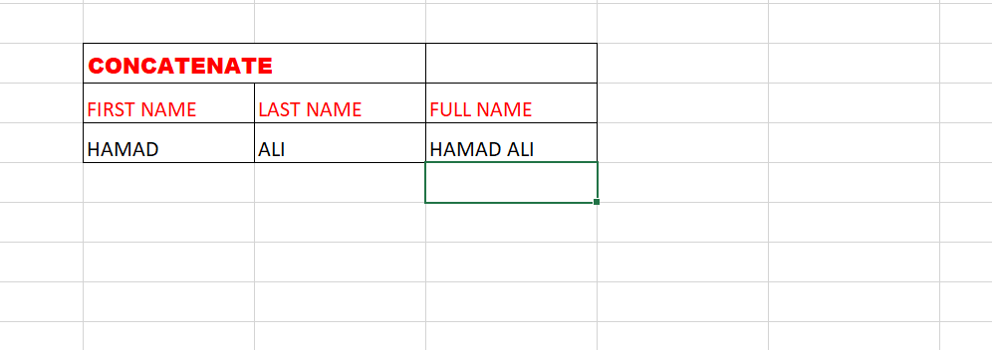

SUMPRODUCT FORMULA

* Open MS EXCEL
* Open a new sheet
* Merge and centre two or more row and columns and add heading of SUMPRODUCT
* Than make 2 or 3 columnsfor items & price
* Then put diff values in diff cells
* After putting values we use formula = SUMproduct( RANGE OF CELLS) and then press enter
* The total is calculated at the point where we use formula.

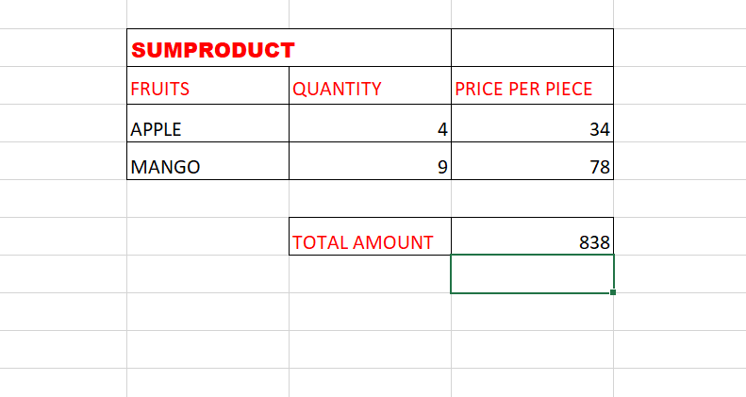

COUNTIF FORMULA

* Open MS EXCEL
* Open a new sheet
* Merge and centre two or more row and columns and add heading of COUNTIF
* Than make 2 or 3 columns
* Then put diff values in diff cells
* After putting values we use formula = COUNTIF( select row.”p”) and then press enter
* The total is calculated at the point where we use formula.

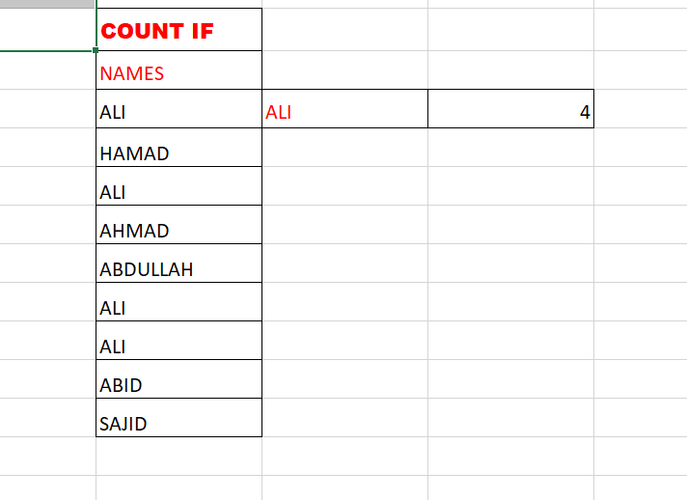

ROMAN FORMULA

* Open MS EXCEL
* Open a new sheet
* Merge and centre two or more row and columns and add heading of ROMAN
* Than make 2 or 3 columns
* Then put diff values in diff cells
* After putting values we use formula = ROMAN( RANGE OF CELLS) and then press enter
* The total is calculated at the point where we use formula.

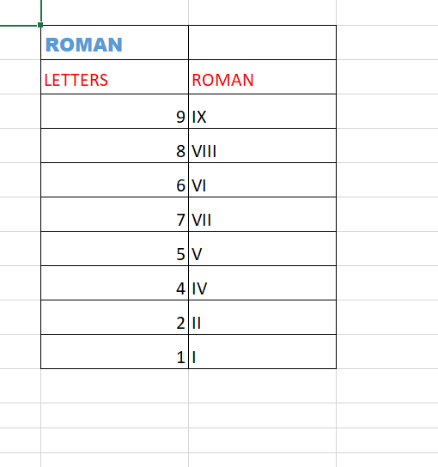

AVERAGE FORMULA

* Open MS EXCEL
* Open a new sheet
* Merge and centre two or more row and columns and add heading of AVERAGE
* Than make 2 or 3 columns
* Then put diff values in diff cells
* After putting values we use formula = AVERAGE( RANGE OF CELLS) and then press enter
* The total is calculated at the point where we use formula.

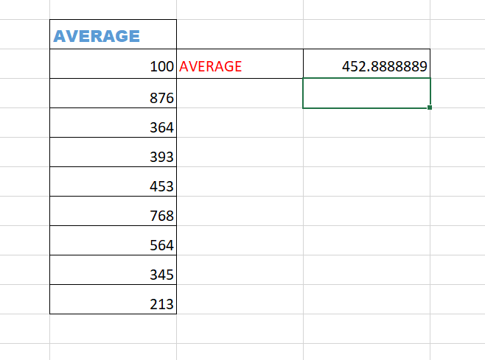

ONLINE LAB

BAR CODE

* Firstly download barcode font from web
* Open ms word
* Type the text in cell
* Than apply formula =”*”& select cell &”*”
* Than press enter
* Your barcode is generated

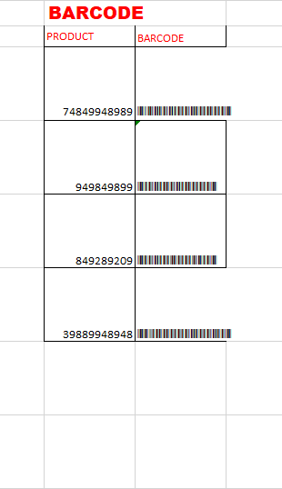

QR CODE

• Open Microsoft Word.

• Go to **Insert**>**Get Add-ins**.

• Search for **QR4Office** and click **Add**.

• In the **QR4Office** pane, enter the text or URL for the QR code.

• Customize size, color, and error correction if needed.

• Click**Insert** to add the QR code to your document.

• Adjust the size and position as desired.

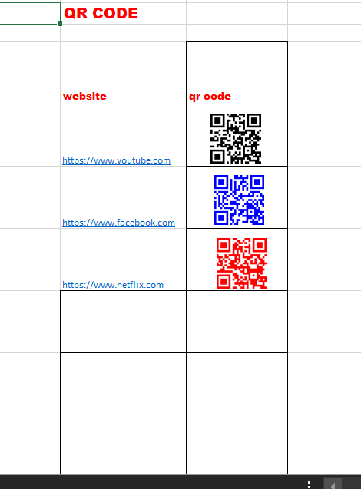

LAB08

CREATING CHARTS & GRAPHS

STEPS FOR CREATING CHARTS IN EXCEL

• Open Excel.

• Enter data into a worksheet.

• Highlight the data range.

• Click the **Insert** tab.

• Select a chart type (e.g., Column, Line, Pie).

• Customize the chart (titles, labels, colors).

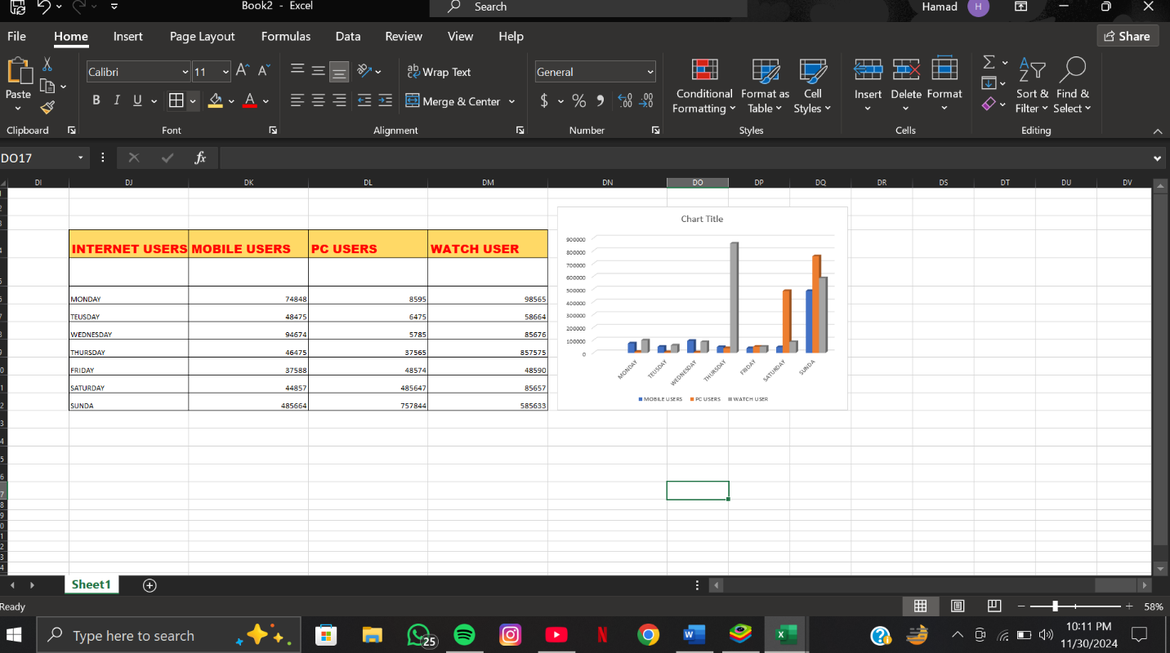

CREATING A PI GRAPH

STEPS FOR CREATING A PI GRAPH

1. Open Excel.
2. Enter data into two columns (category and value).
3. Highlight the data range.
4. Click the **Insert** tab.
5. Select **Pie Chart** from the Chart section.
6. Choose a Pie Chart type (2D, 3D, Doughnut).
7. Click the chart to select it.
8. Add a chart title.
9. Add data labels.
10. Format data labels (percentage, value, etc.).
11. Change the chart colors or styles.
12. Adjust chart size and position.
13. Save the file.

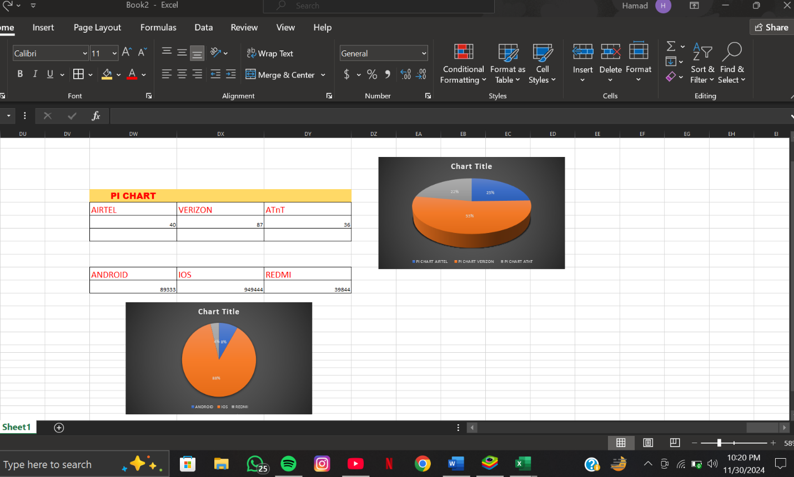

VLOOK UP & HLOOKUP

STEPS FOR V LOOKUP

1. Open the Excel file containing the mark sheet.
2. Identify the cell where you want to display the result.
3. Click on the target cell.
4. Type =VLOOKUP(.
5. Select the cell containing the lookup value (e.g., student’s name or ID).
6. Add a comma ,.
7. Select the range of the mark sheet table (e.g., A2:D10).
8. Add a comma ,.
9. Enter the column number from which to retrieve the data (e.g., 3 for marks).
10. Add a comma ,.
11. Enter FALSE for an exact match.
12. Close the parenthesis ).
13. Press Enter.
14. Verify the result.

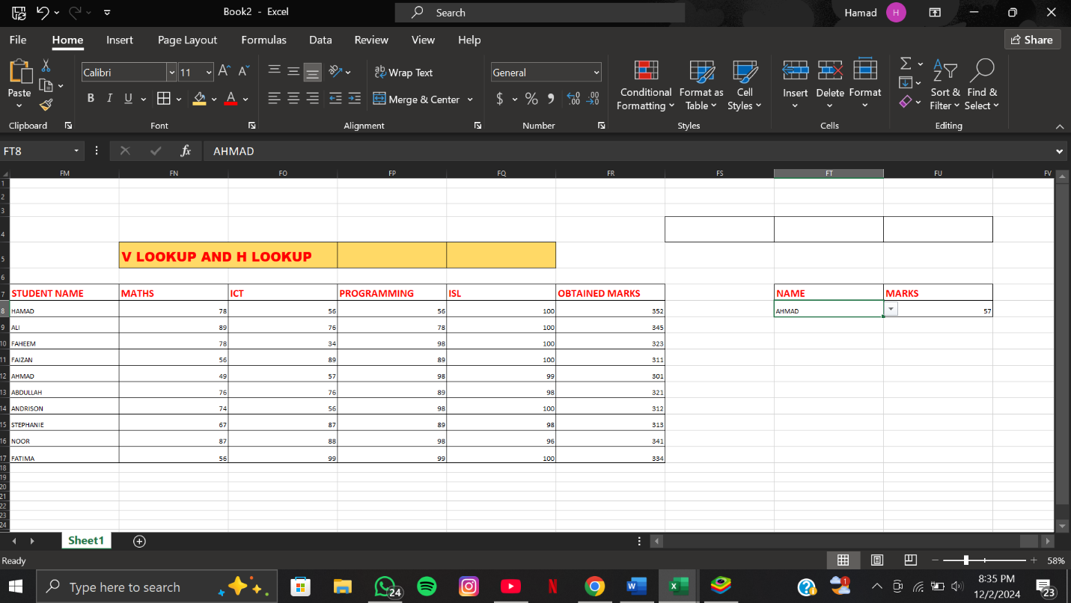

STEPS FOR H LOOKUP

• Open the Excel file containing the mark sheet.

• Identify the cell where you want to display the result.

• Click on the target cell.

• Type=HLOOKUP(.

• Select the cell containing the lookup value (e.g., subject name or code).

• Add a comma ,.

• Select the range of the mark sheet table (e.g., A1:D5).

• Add a comma ,.

• Enter the row number from which to retrieve the data (e.g., 2 for marks).

• Add a comma ,.

• EnterFALSE for an exact match.

• Close the parenthesis ).

• Press Enter.

• Verify the result.

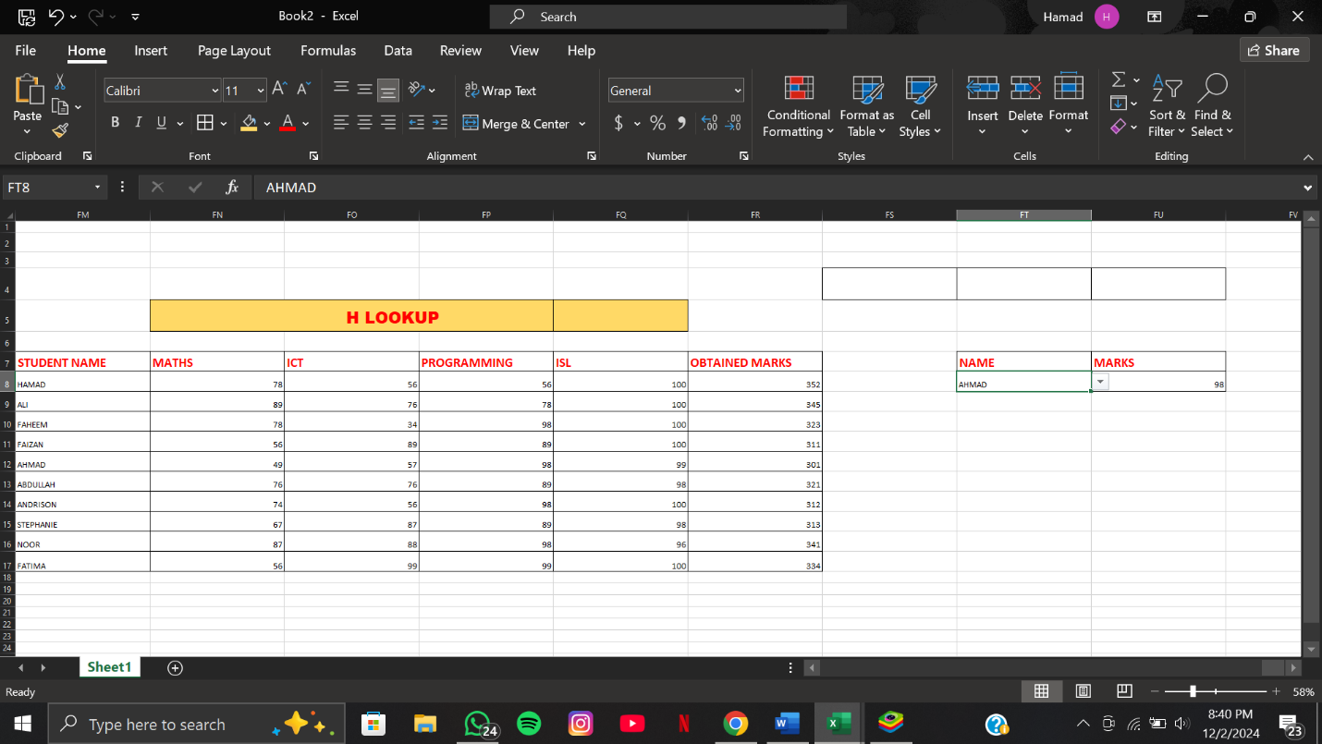

SORTING AND FILTERING

STEPS FOR DOING SORTING

• Select the range of data you want to sort.

• Press Alt + H, then S, and then S again.

• In the "Sort" dialog box, choose the column you want to sort by.

• Select the sorting order (Ascending or Descending).

• Click "OK" to apply the sort.

1. Macros are the recording of data in MS Word.
2.
3. 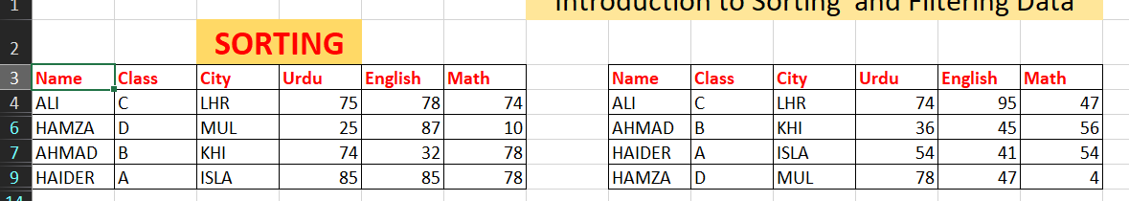

   STEPS FOR DOING FILTERING

   • Select the table range or column header.

   • Press Ctrl + Shift + L to apply filters.

   • Click on the drop-down arrow in the column header.

   • Choose the filter criteria (e.g., text, number, date).

   • Select the desired filter options (e.g., checkboxes or custom filter).

   • Press OK to apply the filter.

   • To remove the filter, press Ctrl + Shift + L again.

   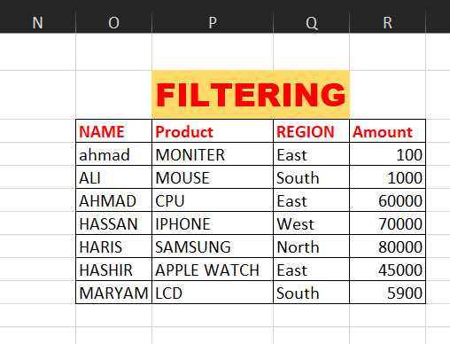

   LAB 09

   CREATING A MANGO THROUGH “ PENCIL “

   STEPS FOR CREATING A MANGO

   1. Start by lightly sketching an oval shape to outline the basic form of the mango. Slightly taper one end to resemble the natural shape.
   2. Add a small curved stem at the top, and draw a leaf extending from it if desired.
   3. Refine the outline by smoothing the edges and adjusting the curves to make the mango look more organic.
   4. Use soft, curved lines to add subtle details, like the indent at the top where the stem connects.
   5. Shade the mango with light strokes to indicate the areas where shadows would naturally fall.
   6. Gradually build up the shading, layering darker tones on the bottom or sides to create depth and a three-dimensional effect.
   7. Blend the shading using your pencil or a blending tool to smooth out harsh lines.
   8. Add finer details, like veins on the leaf or texture on the mango’s surface, with gentle strokes.
   9. Review your drawing and refine the outline or shading as needed for a polished look.

   CANVA

   STEPS FOR CREATING A BUSINESS POST FOR SOCIAL MEDIA PLATFORM IN CANVA

   • **Log In or Sign Up**

   * Go to [Canva's website](https://www.canva.com) or open the Canva app.
   * Log in to your account, or sign up for a free account if you’re new.

   • **Choose a Template**

   * Click on the search bar and type the name of the platform you’re creating for (e.g., "Instagram Post," "Facebook Post," "LinkedIn Post").
   * Browse through the available templates and select one that suits your business's style or purpose.

   • **Customize the Design**

   * **Change Text:** Double-click on the text boxes to add your content (e.g., your business name, promotional message, or tagline).
   * **Add Images:** Replace placeholder images with your product photos or use Canva's library of free and premium stock images.
   * **Adjust Colors:** Match the template’s colors to your brand’s color palette using the color picker.
   * **Choose Fonts:** Use fonts that align with your branding for consistency and readability.

   • **Add Branding Elements**

   * Upload your logo and place it in a prominent but non-intrusive area.
   * Include your website URL, slogan, or contact details if needed.

   • **Incorporate Visual Elements**

   * Add icons, shapes, or illustrations to enhance the design and emphasize key information.
   * Use Canva's animation feature for platforms like Instagram Stories or Reels if motion is required.

   • **Preview Your Design**

   * Check the layout for alignment, readability, and overall appeal.
   * Ensure the post looks good on both desktop and mobile views.

   • **Download the Post**

   * Click on the “Share” or “Download” button.
   * Choose the appropriate file format:
     + **JPG/PNG** for static posts.
     + **MP4** for animated posts.

   • **Post to Your Social Media Platform**

   * Upload your design to the intended social media platform.
   * Add a caption, hashtags, and any other relevant details.

   **For Example:**

   

   LAB 10

   ADOBE ILLUSTRATOR

   STEPS FOR CREATING A PARTY CARD

   1. Open Adobe Illustrator and create a new document with dimensions suitable for your party card.
   2. Choose a background color or pattern by selecting the rectangle tool and filling it with your desired color or gradient.
   3. Add text by selecting the type tool and typing your party details, such as the event name, date, and location.
   4. Choose a font style, size, and color that aligns with the party theme and is easy to read.
   5. Insert decorative elements like shapes, icons, or illustrations using the shape tools or importing vector graphics.
   6. Adjust the arrangement of text and elements using the alignment and distribution tools to create a balanced layout.
   7. Enhance the design with effects like shadows, strokes, or gradients to add depth and interest.
   8. Include any logos, images, or personal photos by importing and placing them within the design.
   9. Use layers to organize different elements and make adjustments easily.
   10. Review the design, make final tweaks, and export the card in your desired format, such as PDF or PNG, for printing or sharing.

   

   LAB 11

   GITHUB

   STEPS FOR UPLOADING YOUR FILE ON GITHUB

   1. Create a GitHub account or log in to your existing account.
   2. Open GitHub and navigate to your repository, or create a new repository by clicking the "New" button.
   3. If creating a new repository, fill in the necessary details, such as the repository name and description, and choose its visibility (public or private).
   4. On your local machine, initialize a Git repository in your project folder by opening the terminal or command prompt and running git init.
   5. Add the files you want to upload by running git add . (to add all files) or git add <file_name> (to add specific files).
   6. Commit your changes by running git commit -m "Your commit message".
   7. Link your local repository to the remote GitHub repository by running git remote add origin <repository_URL>.
   8. Push your changes to GitHub by running git push -u origin master (or main if using the default branch name).
   9. Enter your GitHub username and password if prompted.
   10. Go to your GitHub repository page, where the files should now be visible.

   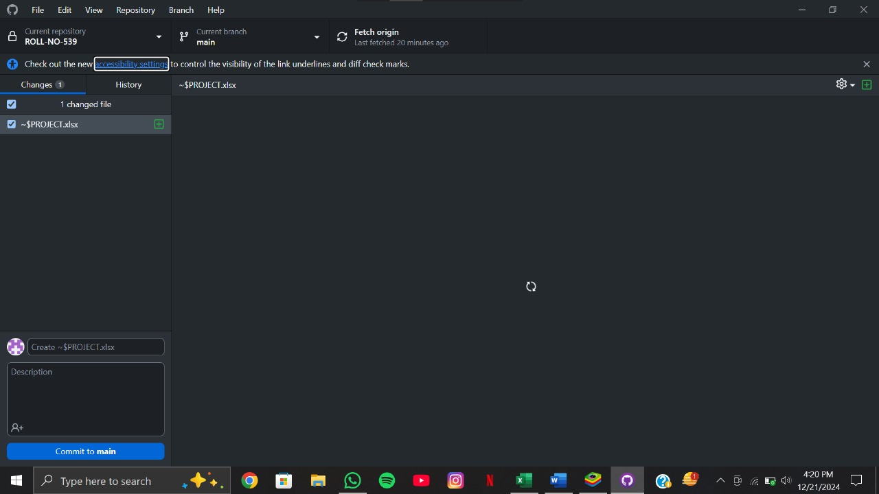

   **THANKYOU**